Different seasons with average productions



Production by Season colored by Season

Season

Autumn Kharif Rabi Summer

Whole Year Winter

2,500,000

2,395,011.98

2,000,000

1,500,000

1,000,000

500,000

0

13,065.67

42,743.34

31,011

11,522.38

71,826.42

Autumn Kharif Rabi Summer Whole Year Winter

Season

Production (Average)

With years usage of Area and production



Area by Crop_Year

1

1,997 1,998 1,999 2,000 2,001 2,002 2,003 2,004 2,005 2,006 2,007 2,008 2,009 2,010 2,011 2,012 2,013 2,014 2,015

Production by Crop_Year

2

1,037,553.77

957,594.7

517,254.54

549,672.33

590,955.53

621,201.57

801,159.56

465,466.57

542,306.28

517,214.53

619,770.54

461,985.73

482,125.05

457,305.05

95,654.89

12,361.97

1,997 1,998 1,999 2,000 2,001 2,002 2,003 2,004 2,005 2,006 2,007 2,008 2,009 2,010 2,011 2,012 2,013 2,014 2,015

## Filter(s) applied to the visualization(s) on the previous page:

**Widget 1**

Crop_Year Includes: 2,013

## Widget 2

Crop_Year Includes: 2,013

Top 10 states with most area



Area by State_Name colored by State_Name

State_Name

1

Andhra Pradesh Gujarat Haryana Madhya Pradesh Maharashtra

Punjab Rajasthan Telangana Uttar Pradesh West Bengal

50,000

40,000

30,000

20,000

10,000

0

Andhra Pradesh

Gujarat

Haryana

Maharashtra

Rajasthan

Uttar Pradesh

Madhya Pradesh

Punjab

Telangana

West B...

State_Name

Area (Average)

13,662.84

18,367

15,250.61

14,375.33

25,515.22

39,938.73

21,737.65

14,402.66

13,019.62

22,407.7

## Filter(s) applied to the visualization(s) on the previous page:

**Widget 1**

Area Top 10

State with crop production

Crop

Apple

Search

Arcanut (Processed) Arecanut

Arhar/Tur Ash Gourd

Atcanut (Raw) Bajra

Banana Barley

Bean

# State_Name for State_Name regions

State_Name

Arunachal Pradesh Assam

Gujarat Himachal Pradesh

Maharashtra Nagaland

Telangana Tripura

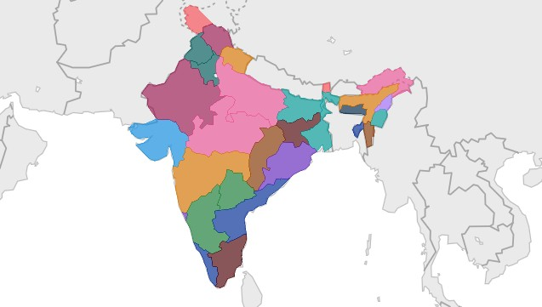

Apply

[© Mapbox](https://www.mapbox.com/about/maps/) [© OpenStreetMap](https://www.openstreetmap.org/about/)

States with the crop production along with season(Text table)



State_Name and Crop

1

Crop

State_Name

Apple

Tamil Nadu

Arcanut (Processed)

Karnataka

Andaman and Nicobar I… Andhra Pradesh

Assam Goa

Karnataka

Arecanut

Kerala Meghalaya Puducherry

Tamil Nadu

Season and Crop

2

Crop

Season

Apple

Whole Year

Arecanut

Whole Year

Kharif

Arhar/Tur

Whole Year

Ash Gourd

Whole Year

Kharif

Bajra

Rabi Whole Year

Kharif

Banana

Whole Year

Beans & Mutter(Vegetab… Whole Year

## Filter(s) applied to the visualization(s) on the previous page:

**Widget 1**

State_Name Includes: Tamil Nadu

## Widget 2

State_Name Includes: Tamil Nadu

Dashboard-crop yield

Season and Crop

Crop Season

Apple Wh

# State_Name for State_Name regions

State_Name Arunachal Pradesh Assam

Gujarat

# Area by State_Name colored by 1

State_Name

State_Name

Andhra Pradesh Gujarat

Haryana Madhya Pradesh

State_Name and Crop

ndhra...

Haryana

Maharashtra

Rajasthan

Uttar Pr...

Gujarat

Tamil

Apple

State_Na

Crop

[© Mapbox](https://www.mapbox.com/about/maps/) [© OpenStreetMap](https://www.openstreetmap.org/about/)

Madhya P...

Punjab

Telangana

Wes...

Arcanut (Proc

Karna

# Production by Season colored by Season

Area by Crop_Year

Production by Crop_Year

1,037,553.77

Season

Autumn Kharif

517,254.54 465,466.57594,996.47542,306.28

95,654.89

619,770.54

801

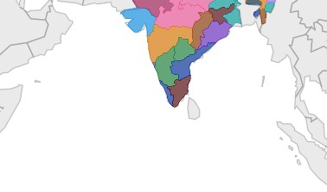

,997 1,999 2,001 2,003 2,005 2,007 2,009 2,011 2,013 2,01

**Filter(s) applied to the visualization(s) on the previous page:**

**Widget 1**

Area Top 10